Austin Johns, David Kisiel, Jared Wermager

CST-217

April 3, 2019

William Hurst

CLC-TSQL Development

Create a stored procedure to insert data into one or more tables of your database.

Create a stored procedure to delete data from one or more tables of your database.

Create a stored procedure to update data in one or more tables of your database.

As seen in the first screenshot, we began creating a procedure to insert data in the table. We called this procedure “AddUser”. This allows the system to add a user with important details.

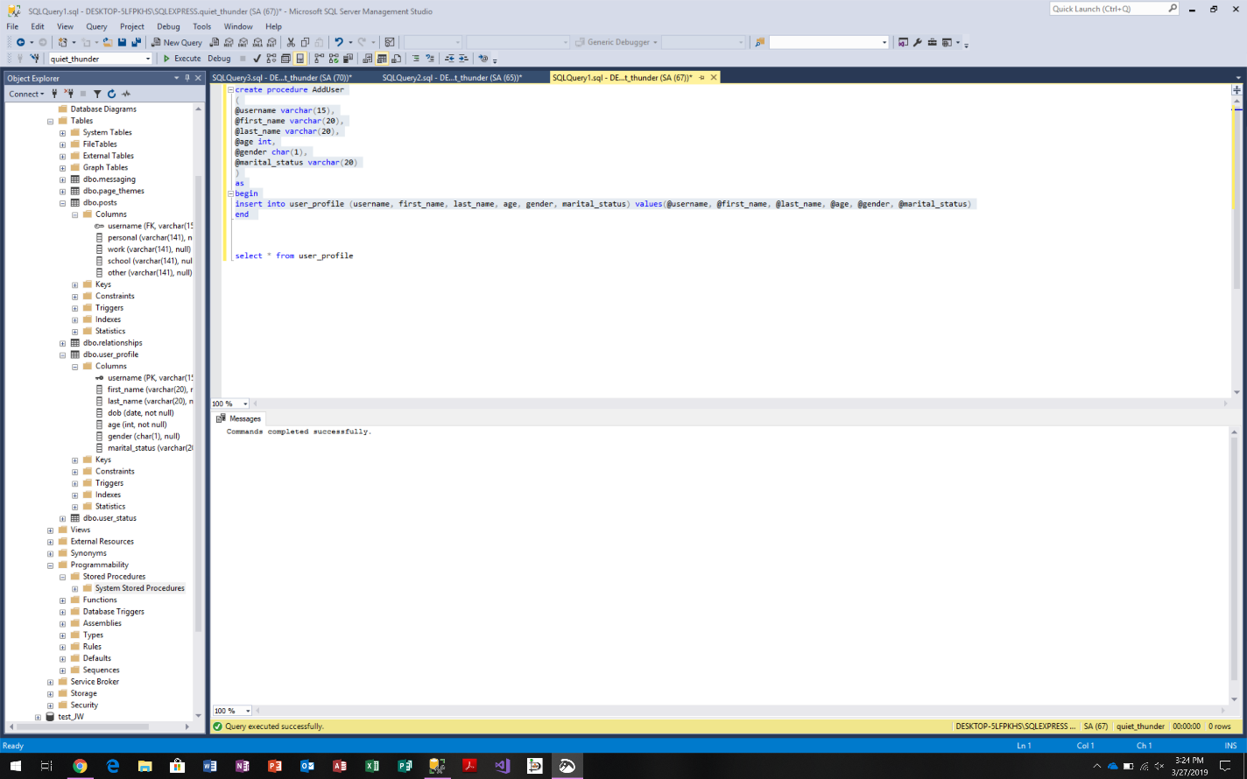

In this screenshot, we are creating a procedure to delete data from a table. When executing this procedure, the user just needs to choose delete and the procedure will delete data associated with a user.

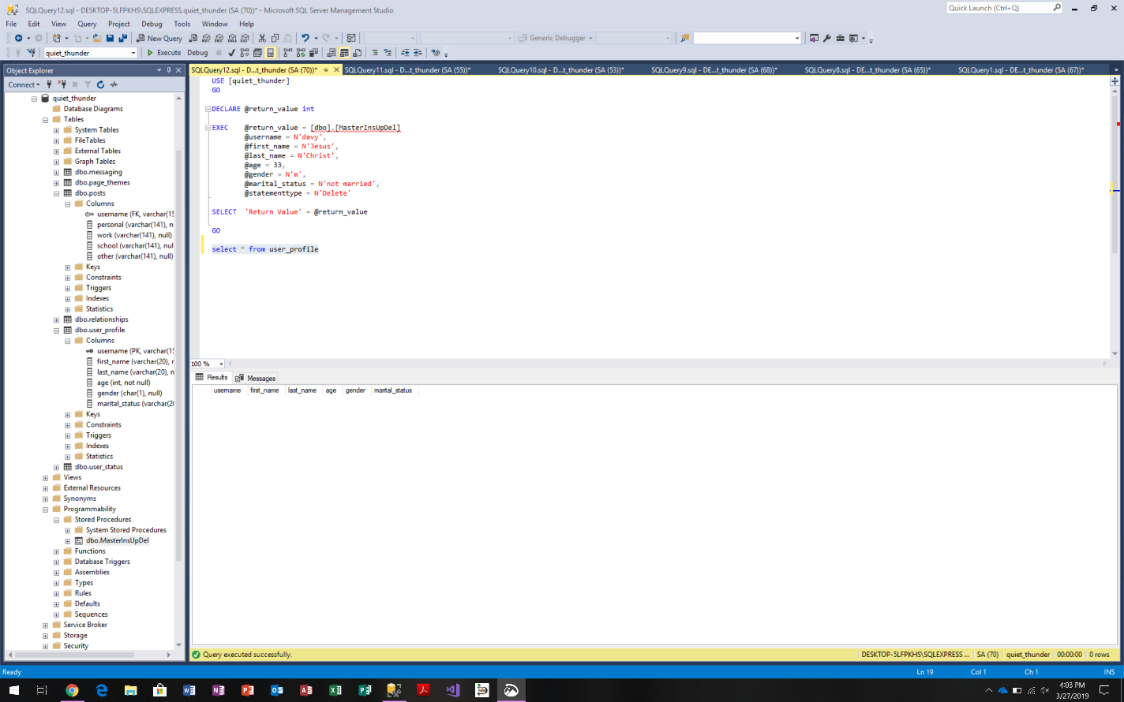

In this screenshot, the procedure will be used to update data for any given user in the system. The user of the database can input a name and update the information for the user in the system. The user updating the system just needs to specify that they would like to update a user rather than create a new one.

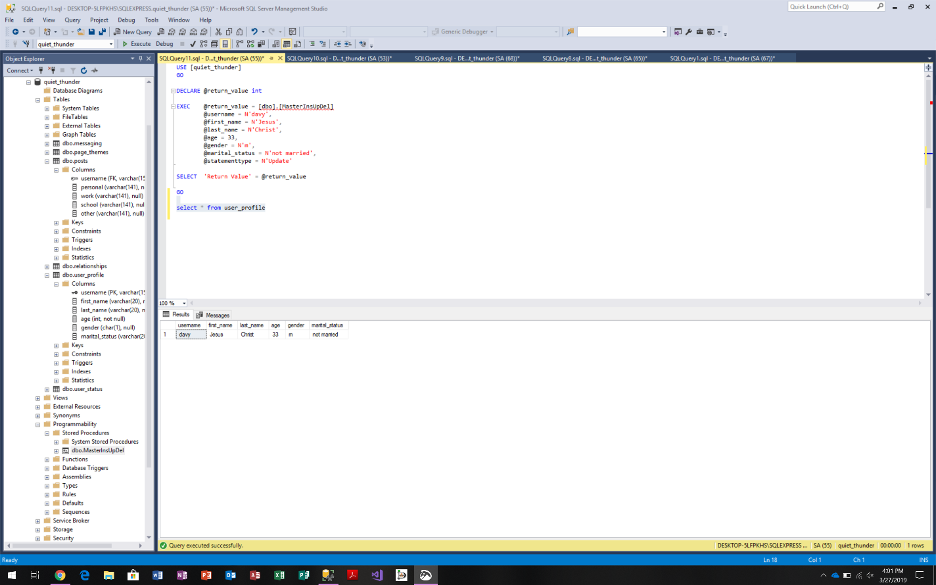

In these next two screenshots, we are creating a UDF. In this function, the user can retrieve any amount of information for any range of data. For example (seen in the second screenshot), the user can view product models with IDs between 75 and 80. All the user has to do is specify product ID in this case.

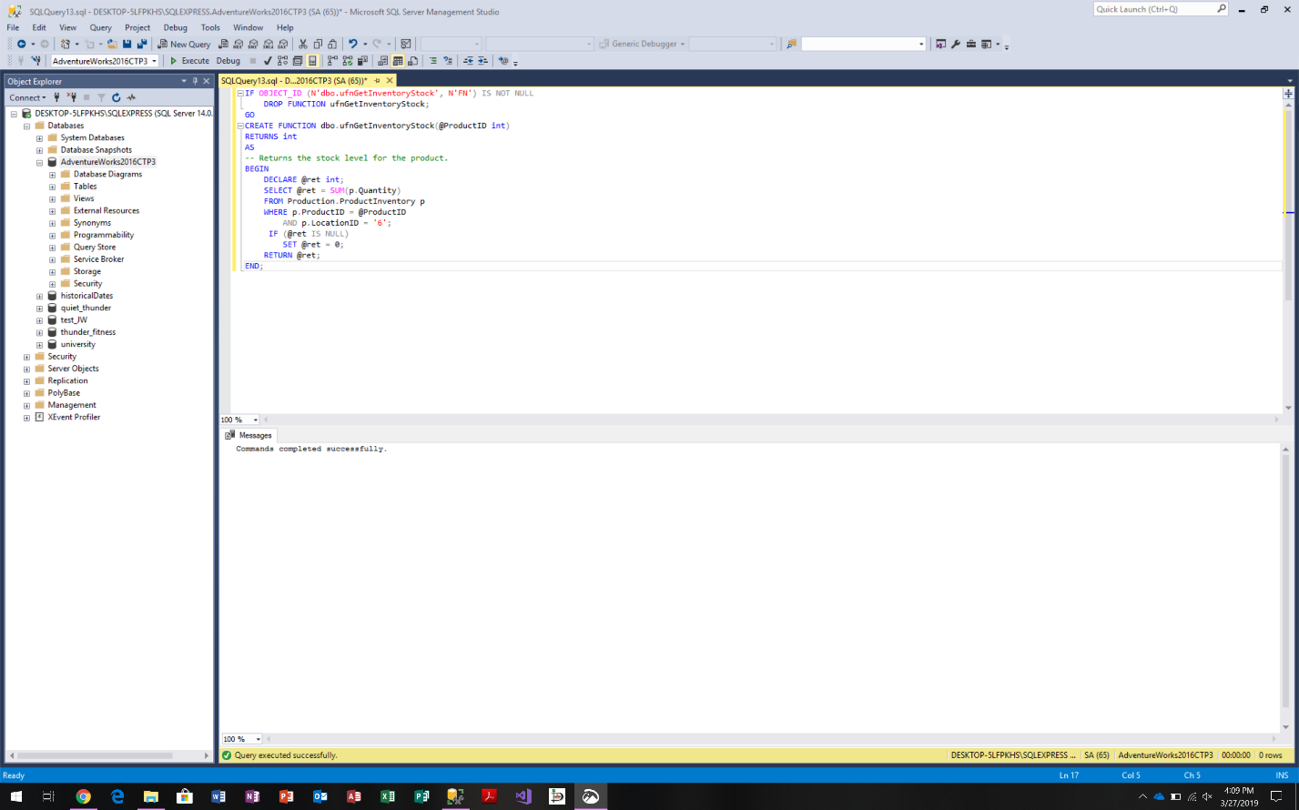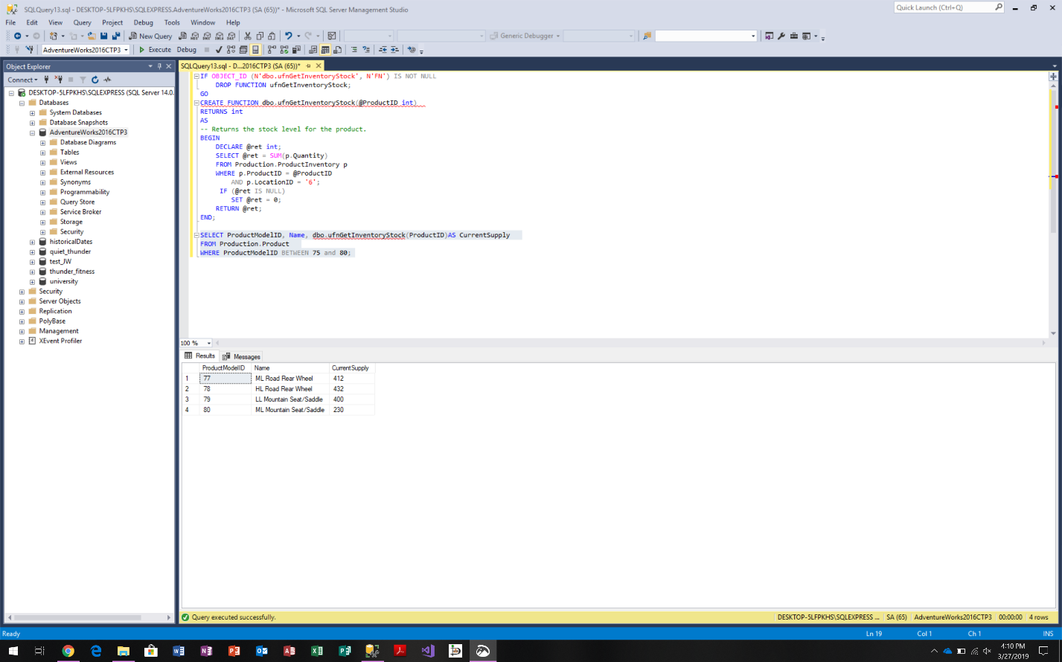

In this screenshot, the user is able to update any number of records based on another table in the database. In this table, the vacation hours were updated using the update cursor.

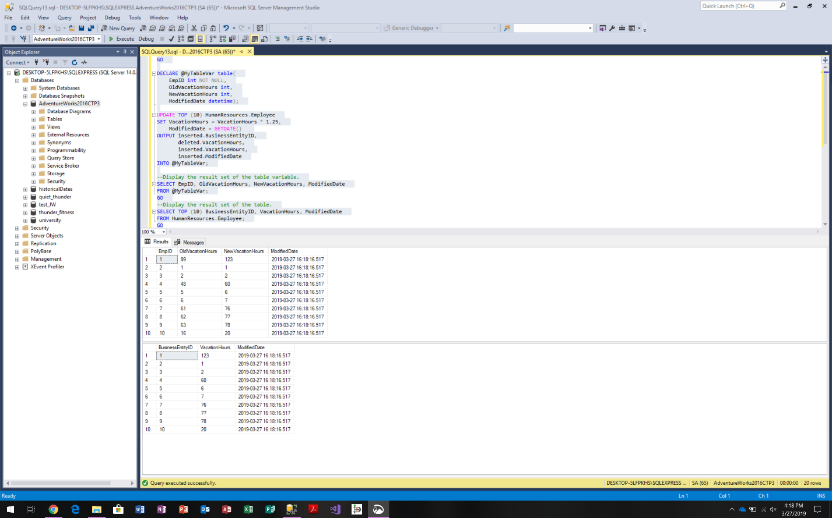

In the next two screenshots, the logging trigger is used to record purchasing history for any given purchase that pertains to the database.

